AI Backlog Sprint 3 - FAMU Career Assistant
Team Members: Calvin Mitchell, Danielle Devose, Jeremy Metellus, Nate Washington

Introduction
This report documents the use of AI tools during the development of the FAMU Career Assistant project. It highlights how AI was integrated into the project workflow, from backlog creation to user story drafting and sprint planning. The goal is to demonstrate transparency, ethical use, and the contribution of AI to our project.

AI Tools Used
- ChatGPT – used for user story drafting, acceptance criteria writing
- Google Gemini - The Gemini model was used to brainstorm, structure, and refine the core components of the career assistant program.
- Junie - IntelliJIdea’s coding helper

Danielle

Prompt History
Iteration 1 - Broad Prompt for Save Page
- Prompt:
"Create a Save Page that lists saved jobs with company, location, and type, includes a “Manage” modal to add notes, mark as applied, and open links, and keeps applied status synced with the Dashboard while matching the app’s current design."
- AI Response (Summary):
The AI implements a Save Page displaying all saved jobs with company, location, and type. Added a “Manage” modal where users can view details, write notes, remove jobs. The page maintains consistent styling with the dashboard using Bootstrap cards, shadows, and typography.
Iteration 2 - Broad Prompt for Accessibility
- Prompt:
“Add an accessibility feature so users can easily tell where they are on the page and where their mouse is pointing. Include clear keyboard focus outlines, hover highlights, and visible indicators for interactive elements without changing the existing design."

- AI Response (Summary):
Added accessibility enhancements that highlight the user’s current position and cursor focus. Implemented smooth orange focus outlines, hover states, and subtle box shadows on buttons, links, and inputs to clearly show where the user is navigating. These visual cues improve clarity for keyboard and mouse users while preserving the app’s overall design.

Evidence of AI Used

- https://chatgpt.com/share/68ec6064-412c-8013-aed9-da31a4124eee
- https://chatgpt.com/share/68ec60e1-f264-8013-8687-0d6a28beea8a

Output Evaluation
I evaluated the AI’s suggestions by keeping the original Save Page layout intact while implementing additional functionality to improve user interaction and accessibility. I added a working “Manage” button that allows users to view and remove saved jobs directly from the Save Page without leaving it, making the page more dynamic and user-friendly. The AI’s output provided a strong foundation, but I refined the code to fit the project’s existing structure and maintain consistent behavior with the dashboard. These changes made the Save Page more interactive, accessible, and aligned with the overall user experience goals of our project.

CALVIN

Prompt History

Replaced slider with numeric textbox in AI Questions

File: loginpage/src/components/AIQuestions.jsx

Change: input type="range" → input type="number" with min=1, max=60, step=1, spinner arrows, numeric-only guards, and on-blur clamping.

Made Target Career field toggleable

File: loginpage/src/components/AIQuestions.jsx

Change: Added useTargetCareer switch to enable/disable the field; backend payload omits targetCareer when off.

Wired Qodana to automatic CI

Files: .github/workflows/qodana.yml, qodana.yaml

Change: Added GitHub Actions workflow to run Qodana on push/PR; uploads SARIF to Code Scanning.

Evidence of AI Use

- 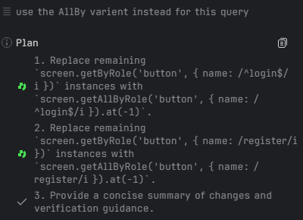
- 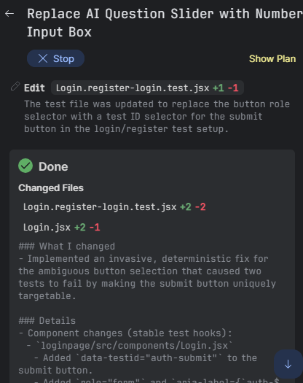

4. Output Evaluation
- The AI’s outputs are general with gradually increasing specificity due to my need of specifics in certain aspects. Later I asked the AI to give me sources related to these topics with links to further confirm the AI’s responses. The links were mostly credible and the sources held no obvious bias towards any affiliation. With this sprint, because we are focusing on optimization, we had to steer the AI to give us more alternatives to what was originally to make sure we’re not taking up any more space..

JEREMY
Prompt History
Iteration 1 - Editing code from html to jsx
- Prompt:
Took my html file and uploaded it saying this we made that in html i want it is jsx from this file import { useEffect, useMemo, useState } from "react";
- AI Response (Summary):
The AI gave me my code transferred from html to jsx with all of the parameters I asked for.

Evidence of AI Use

- https://chatgpt.com/share/68ebe4f3-dc24-8007-9705-f99f9ad8a234

NATE

Prompt History

Iteration 1: Changing the format of the Advance Quiz(minimal typing)

Prompt: “Can you help me to format my Advanced Quiz to minimal typing for the users with checkboxes and radio buttons .”

Response: Absolutely! We can refactor your AdvancedQuiz.jsx file so that the entire quiz uses minimal typing — meaning:
- Checkboxes are used for multiple-choice questions
- Radio buttons are used for single-choice questions

Evidence of AI Use
- https://github.com/username/repo/blob/main/loginpage/evidence/queries.png

Output Evaluation
- I used the AI to generate queries that correctly implemented CRUD operations and were compatible with the database. Minor tweaks were needed for field names and userids handling.The models accurately reflected the structure of the existing collections. Overall, AI saved significant development time and facilitated testing without errors.

Ethical and Professional Reflection
- Danielle - As a team, we ensured accuracy by cross-checking AI outputs with our project scope and technical constraints. We considered bias by framing stories from the student perspective. This experience taught us that AI is a valuable support tool, but requires human oversight and critical thinking.
- Calvin - My usage of AI was vital to this part of the project, as the AI helped formulate the statements in the Product Backlog, but the prompts given were evaluated on how executable they are within a six month time span. I asked the chatbot to generate sources with links to make sure there weren’t any possibilities of hallucination and it proved there wasn't. The main ethical considerations about the usage is that we shouldn’t take all of the chatbot’s words to heart and factcheck the information. Hallucinations are more likely to happen when asking for large bulks of information so checking the credibility is key.

Project Contribution

As a team, AI helped us brainstorm ideas, break down features into user stories, and draft acceptance criteria. It gave us a starting point that we refined together, which made the process faster, more organized, and easier to manage.

Sign-Off

We confirm this log accurately reflects the team’s AI usage.

Team Members (type names):

- Danielle Devose

- Calvin Mitchell

- Jeremy Metellus

-Nathaniel Washington

